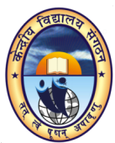 | 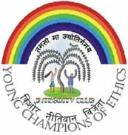

INTEGRITY CLUB

An activity for rekindling Human Values in School Children

Download the documents:

• Integrity Club Brochure

• Integrity Club Booklet

• Integrity Club Manual

Message from Commissioner, KVS

