Achievement of KV Teacher

Mr. Anutosh Deb, Art Teacher, KV Maligaon, Guwahati has been invited to participate in an Inter Cultural Programme to share different points of view about languages, religion, traditions among Indians living in Italy and Indians living in India. He has been invited in recognition of his constant good work on ThinkQuest platform involving students. He has been invited by Istituto Compressive Statale Palombara Sabina, Rome, Italy from 8th to 11th June 2009. Mr. Deb has also visited Singapore and Italy in 2008 and 2007 respectively.

Mr. Deb is a hard working teacher and heading several on-line projects involving different students. He is also recipient of several awards in recognition of his multifaceted works. KVS is extremely proud on his achievements.

Congratulation to Mr. Anutosh Deb

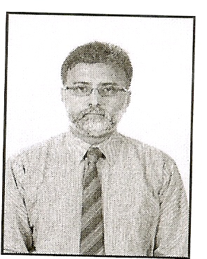

Mr. Anutosh Deb

KV NFR Maligaon

