Recognition For Outstanding Work By KV Teacher (Times Of India Of 5th June, 2008 )

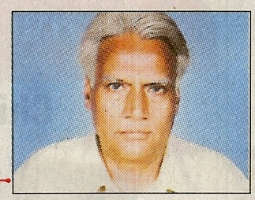

Outstanding work in Mathematics by Shri Ram Gupta, a KV teacher working in KV Jhansi has been appreciated not only by NCERT and MHRD but also by American Mathematical Society. Shri Ram Gupta has been lauded for extending Menelaus Theorem and Cyclic Polygons Theorem universalizing their applicability. His work is of great use for architects in Planning projects and is also the first ever copy right in geometry. We congratulate Shri Ram Gupta for his sincerity and hard work.

